DECLARATION ii

CERTIFICATION iii

DEDICATION iv

ACKNOWLEDGMENTS v

ABSRACT vi

TABLE OF CONTENTS vi

LIST OF FIGURES vii

LIST OF TABLES viii

LIST OF PLATES ix

CHAPTER ONE 1

1.0 INTRODUCTION 1

1.1 BACKGROUND OF STUDY 1

1.2 STATEMENT OF PROBLEM 2

1.3 RESEARCH, AIM AND OBJECTIVE 3

1.3.1 Aim 3

1.3.2 Objectives of the study 3

1.4 SCOPE OF THE STUDY 3

1.5 SIGNIFICANCE OF STUDY 4

CHAPTER TWO 5

2.0 LITERATURE REVIEW 5

2.1 INTRODUCTION 5

2.2 CONCRETE 6

2.2.1 Types of Concrete 7

2.3 COMPOSITION OF CONCRETE 8

2.3.1 Cement 8

2.3.2 Aggregates 9

2.3.3 Classification of Aggregate 10

2.3.4 Water 17

2.4 WASTE CERAMIC RECYCLING 18

2.4.1 Properties of Crushed Ceramic Tiles 19

2.5 RESEARCH WORK 20

`CHPTER THREE 26

3.0 MATERIALS AND METHOD 26

3.1 RESEARCH MATERIALS 26

3.1.1 Cement 26

3.1.2 Fine Aggregate 26

3.1.3 Coarse Aggregate 26

3.1.4 Crushed Ceramic Tiles 27

3.1.5 Water 28

3.2 METHODS 28

3.2.1 Mix Design 28

3.2.2 Sieve Analysis 29

3.2.3 Concrete Production 31

3.2.4 Slump Test 32

3.2.5 Curing 33

3.2.6 Water absorption 34

3.2.7 Compressive Strength Test 35

CHAPTER FOUR 37

4.0 RESULT AND DISCUSSION 37

4.1 Sieve Analysis 37

4.2 Slump Test 41

4.3 Water Absorption 42

4.4 Compressive Strength 44

CHAPTER FIVE 50

5.0 CONCLUSION AND RECOMMENDATION 51

REFERENCE 52

**LIST OF FIGURES**

Figure 4.1.1: Sieve analysis chart for fine aggregate and crushed

ceramic tile 39

Figure 4.1.2: Sieve analysis chart for coarse aggregate 40

Figure 4.2.1: Chart showing the percentage replacement against slump value 41

Figure 4.3.1: Chart of water absorption showing varying percentage passing against weight for all curing period 43

Figure 4.4.1: Compressive Strength for 0% replacement 44

Figure 4.4.2: Compressive strength for 5% replacement 45

Figure 4.4.3: Compressive Strength for 10% replacement 46

Figure 4.4.4: Compressive Strength for 15% replacement 47

Figure 4.4.5: Compressive Strength for 20% replacement 48

Figure 4.4.8: Compressive Strength for varied percentage replacement 49

**CHAPTER ONE**

**1.0 INTRODUCTION**

**1.1 BACKGROUND**

Concrete is a composite material composed of; aggregates, binder(cement) and water all mixed together in specific proportions to form a homogenous material. Concrete is flexible and therefore provide designers and constructors with capacity to create aesthetic and serviceable buildings and structures. Aggregates are extracted from quarries and transported to construction sites. Quarrying has environmental impacts as it uses up energy and leads to emission of carbon dioxide.

Aggregates used in concrete are of two categories:

* Fine aggregate (sand) comprises of natural sand or crushed rock with particle sizes less than 4mm.
* Coarse aggregates ( gravel ) with particle sizes greater than 5 mm Aggregates used in concrete are inert materials that are durable due to their high resistance to physical, chemical and biological dilapidation forces.

Ceramic wastes possess similar traits and can thus be investigated to be incorporated in concrete.

Conventional fine aggregate is obtained from:

* Natural sand in river valleys after it has been detached by the water from parent rock (natural disintegration) and has been deposited in the middle stage of a river.
* Crushing rocks or gravel.

Excavation for these raw materials causes environmental pollution by degradation of the earth surface and encouraging soil erosion. Gaping holes are left after excavation of virgin aggregates. This rugged environment is a visual intrusion to environmental conscious persons.

Construction and Demolition (C&D) wastes contribute the highest percentage of wastes worldwide (75%). Furthermore, ceramic materials contribute the highest percentage of wastes within the C&D wastes (54%) (Limbachiya, 2004). The current option for disposal of ceramic wastes is landfill. This is due to unavailability of standards, avoidance of risk, lack of knowledge and experience in using ceramic wastes in construction. This is where my project comes in:

The need to sustain human development by using natural resources should also correspond to protection of natural environment in order to sustain sustainable use in the present and future generation. The use of alternative materials from discarded waste or recycled material is geared to fulfil this need. Construction industry can handle most of the ceramic waste produced from anthropogenic activities as well reduce rate utilization of quarried natural resources. Use of ceramic waste in concrete is not only economical but also it solves disposal issues.

**1.2 STATEMENT OF PROBLEM**

Rapid industrial development has increased rate of depletion of natural resources and increased dump sites. Waste materials generated during construction and demolition of structures can cause serious problems due to costs associated with disposal and environmental pollution. The rate of environmental degradation can be reduced by diversifying materials and sources of aggregates for convectional aggregates extracted from quarrying. Materials such as ceramic waste are a usable substitute for conventional aggregate. However, there is lack of adequate information regarding to the use of ceramic waste as fine aggregate. There is need to analyse and document the engineering of properties of concrete formed by using waste materials as fine aggregate; this report evaluates its propert

**1.3 RESEARCH AND OBJECTIVES**

**1.3.1 Aim**

The current study aims to determine properties of concrete produced by use of crushed ceramic waste as fine aggregate so as to increase its use in constructions.

**1.3.2 Objectives**

* To design concrete mixes for class 15 concrete.
* To determine compressive strengths of ceramic concrete and compare with that of control mixes.
* To determine the water absorption of ceramic concrete
* To determine slump of ceramic concrete and compare with that of control mixes.

**1.4 Scope of the Study**

The study focused on the comparison of engineering properties of concrete made by using sand as fine aggregate with crushed ceramic waste as fine aggregate and determining the effect of 5%, 10%, 15% and 20% substitution of sand with crushed ceramic waste.

**1.5 SIGNIFICANCE OF STUDY**

Modern development has diversified concrete manufacturing, which has indirectly affected aggregate consumption. Development also increases concrete production. In these conditions, relying on a single aggregate supply is not optimal because demand will rise and natural aggregate will become scarce. Therefore, several alternatives should be developed for preparing future aggregate demand effects. Thus, the significance of the study is listed below:

1. This study examines the effectiveness of the use of crushed ceramic tiles produced from concrete waste in order to test the strength and suitability.
2. This study examines the effect of the curing days on the compressive strength of the concrete produced from the crushed ceramic tiles.
3. This study is aimed at the conservation of our natural resources and the reduction of waste generated in the environment.
4. The problems of only getting aggregate from one place

**CHAPTER TWO**

**2.0 LITERATURE REVIEW**

**2.1 INTRODUCTION**

The literature review includes the necessary background information on concrete in general, as well as the materials utilized in the production of concrete, with a heavy emphasis on concrete aggregates (Fine aggregate in particular). The production, origin, qualities, and characteristics of the aggregates are examined. In addition, context was provided for ceramic waste. The literature review illustrates the current state of knowledge and effective applications of alternative materials utilized in the manufacture of concrete. Because of the nature of the research, a number of journals, articles, and books were found that covered all of the subjects that were relevant to the scope of the research. A significant amount of research has been carried out on the topic of concrete because of the pervasiveness of the term and the importance it plays in the construction sector. Regarding crushed tiles that was generated from Construction and demolition of buildings, a variety of literature was published on a variety of topics. These topics included how the ceramic tiles could be obtained, how this ceramic waste could be incorporated into the new concrete

**2.2 CONCRETE**

Concrete is a composite material comprised of fine and coarse aggregate linked with a fluid cement (cement paste) that hardens (cures). Concrete, second only to water, is widely used in building. (Gagg, 2014). Concrete is an artificial material that resembles stone. Concrete comes from the Latin term "Concretus," which meaning "to grow together" (Li, 2011). It is a key material used in the construction sector to build buildings, dams, bridges, culverts, kerbs, and roads, among other things. Concrete is a mixture of cement, fine and coarse aggregate, and water, mixed in a specific proportion to obtain a specific strength. (Kolo, 2015). When the aggregates are combined with dry Portland cement and water, a fluid slurry is formed that can be easily poured and shaped into various forms. The cement interacts with the water in a process called "concrete hydration" to generate a hard matrix that links the components into a durable stone-like substance (Li, 2011). Concrete is renowned for being economical, a material that hardens at ambient temperature, and castable, with outstanding water resistance, high-temperature resistance, the capacity to consume water, and the ability to work with reinforcing

steel, etc (Li, 2011). Widespread use has caused many environmental impacts. Notably, illegal aggregate mining, such as sand and hardcore mining, increases surface runoff and poses public health risks from toxic chemicals.

**2.2.1 Types of Concrete**

i. Plain concrete (Ordinary concrete)

ii. Polymer concrete

iii. Fiber-reinforced concrete

iv. Self-consolidating concrete

v. Glass fiber reinforced concrete

vi. Ready-mix concrete

vii. Energetically modified cement

viii. Shotcrete

ix. Prestressed concrete

x. Roller-compact concrete

xi. Pre-cast concrete

xii. High density concrete.

**2.3** **COMPOSITION OF CONCRETE**

There are basically four compositions within a concrete mix and they include:

1. Binding materials (Cement)
2. Aggregates or Inert materials (Fine aggregate and Coarse aggregate)
3. Water
4. Admixture (Optional).

**2.3.1 Cement**

Binding material is the most important component in a concrete mixture. Cement is the most used adhesive substance. When water and cement are combined, a paste is produced that coats the aggregates in the mixture. The paste solidifies, bonds the aggregates, and forms a product resembling stone (Raqifa, 2011). Cement usually binds sand and gravel (aggregate). Building cement is usually inorganic, based on lime or calcium silicate, and hydraulic or non-hydraulic depending on its ability to set in water. Concrete has 10–15% cement. (PCA, 2019). Hydraulic cement is any cement that solidifies in water and does not dissolve. Hydraulic cements harden and stick when dry components and water react. Insoluble in water, mineral hydrates are chemically resistant and water-resistant. These are waterproof. (Katz, 2003). The most common type of hydraulic cement is standard Portland cement, a finely ground substance that acquires its binding capability when exposed to water. Lime, silica, alumina, and iron oxide are utilized as raw materials in the production of Portland cement.

**2.3.2. AGGREGATE**

Aggregate is a broad category of coarse to fine-grained construction materials that includes sand, natural gravel, and crushed stone. Air-cooled blast furnace slag, bottom ash, and recycled aggregates from construction, demolition, and excavation waste are increasingly allowed to partially replace natural aggregates. Aggregates are mined most composition of concrete. Aggregates are widely used in drainage constructions such as foundation and French drains, septic drain field, retaining wall drains, and roadside edge drains due to their relatively high hydraulic conductivity value compared to the majority of soils.

Foundations, roads, and rail lines are also built on aggregates. Aggregates are used as a stable foundation, roads/railroads with predictable, uniform properties (e.g., to prevent differential settlement under a road or building), or a low-cost extender that binds with more expensive cement or asphalt to form concrete.

Aggregate with a very uniform particle size distribution has the largest voids, whereas the addition of aggregates with smaller particles tends to fill the voids. The binder must both fill the spaces between the aggregates and adhere the aggregates' surfaces together; it is typically one of the most expensive components. Consequently, aggregate size variation affects both the strength and the cost of concrete (Mehta, 1993).

60% to 80% of the volume and 70% to 80% of the weight of concrete is composed of aggregates (Mehta, 1993). The thermal, elastic, and thermal stability of concrete depend on aggregate, an inert filler. Most concrete aggregates are several times stronger than other components, so they do not affect normal concrete strength. Before mixing concrete, aggregate's physical and mineralogical properties—shape and texture, size, gradation, moisture content, specific gravity, reactivity, soundness, and bulk unit weight—must be known along with the water-to-cement ratio, these characteristics determine the strength, workability, and durability of concrete.

Aggregate shape and texture affect fresh concrete more than hardened concrete. Smooth, rounded aggregate makes concrete more workable than rough, angular, or elongated aggregate. Smooth or rough aggregate surface texture. A smooth surface improves workability, while a rougher surface strengthens the paste-aggregate bond, increasing strength.

Aggregates are often thought of as inert filler in concrete, but their properties affect its strength, durability, workability, and cost. These diverse aggregate properties give designers and contractors the most design and construction flexibility. Aggregates are used in large quantities to make concrete, which depletes our natural resources. (Kosmatka, 1994)

**2.3.3. Classification of Aggregates**

Aggregates can be classified into:

1. Natural aggregates.
2. Artificial aggregates.
3. Normal aggregates.
4. Light aggregates.
5. Heavy aggregates.

Natural Aggregates

They are obtained from natural sources e.g. river deposits, gravels, sand and rocks. The geological processes by which a deposit was formed are responsible for its shape, size, grading, rounding and degree of uniformity of the aggregates. Various rock types when crushed are suitable for use as aggregates.

These include;

Limestone: Are sedimentary rocks chiefly composed of calcium carbonate. The harder and denser types particularly the carboniferous types are suitable for concrete. Less hard types are unsatisfactory.

Igneous rocks: The most common are the granites, basalts and gabbros. Granitic aggregates are commonly because they are hard, tough and dense and are excellent in bonding with cement. Although it’s excellent in concrete production, its overexploitation has adversely affected the environment thus the need for research on alternatives.

Metamorphic rocks: They have variable characteristics. Marbles and quartzites are usually massive, dense and adequately tough thus provide good aggregates. However schists and slates are often thinly laminated and are therefore unsuitable. Other rocks such as shale and sandstones among others are rarely available. Shales are poor aggregates because they are weak, soft and absorptive. In sandstones, imperfect cementation of constituent grains makes some sandstone friable and very porous thus unsatisfactory aggregates. Since natural aggregates are formed by geological processes or by crushing rock, their many properties depend on the properties of the parent rock e.g. chemical and mineral composition, petrology, specific gravity, hardness, strength, pore structure, colour etc. these properties have a considerable influence on the quality of fresh and hardened concrete.

Artificial Aggregates

These are manufactured mainly from industrial byproducts, waste materials or sometimes natural materials. They are mainly lightweight aggregates. Examples are;

Pulverized Fuel or Fly Ash (PFA): This is the residue of the combustion of pulverized coal used as a fuel in thermal power stations. **PFA** is used in the manufacture of lightweight aggregates in Germany and Great Britain to reduce dead loads of high-rise structures (L.J. Murdock 1991). **PFA** powder is pelletized with water in a rotating pan and the pellets burnt in horizontal grate at a temperature of 1200-13000C. They are then cooled and screened in different particle size fractions.

Foamed slag: This is a by- product in the manufacture of pig iron in blast furnace. The slag is transformed into molten state at 1400-15000C. Steam and compressed air is injected in the process. This produces numerous bubbles which causes the slag to expand so that on cooling it becomes an artificial rock like material with cellular structure – internally porous and honey combed (The concrete society 1980). The artificial rock is then crushed and screened to give different particle sizes.

Sintered Glass aggregates: They are manufactured mainly north of France. The raw material used comes from waste glass bottles. The bottles are crushed, dried and ground in a rotary mill at a fineness of 3600cm3 /g Blaine. Before grinding, 2.5% of calcium carbonate (CaCO3) is added as an expansive agent. The powder is well homogenized and pelletized with water in a rotary pan. According to the speed and inclination of the pan, it is possible to obtain several diameters. The pellets are then dried in hot air and pre-heated up to 6800C and passed quickly through a rotary kiln at 8000C. They are then cooled and screened (The concrete society Ci80, 1980).

Furnace Clinker: It comes from the combustion of coal in domestic or firing systems. The clinker is sometimes used as lightweight aggregate after being crushed and screened. Aggregates are dark in colour with a sintered or slaggy appearance. This type of aggregate is relatively little used due to its stability which must be verified by chemical and physical testing. It must not contain harmful substances like burnt lime and magnesia, sulphides, and sulphates which are deleterious in concrete.

Other artificial aggregates

* Wood aggregates (industrial production in Eastern France and Switzerland).
* Expanded minerals aggregates – clay, shale and slate (great developments in Europe).
* Rice balls (Researches being made).
* Expanded polystyrene (Expensive polystyrene limits production).
* Vermiculite (industrial production, though minimal, in Netherlands, Italy, France and Belgium).
* Cork aggregates (Major developments in Spain and France)

Normal Weight Aggregates

Many natural aggregates, from granites, gravels, basalts, limestone among others fall under this category. All these aggregates have specific gravities within a limited range of 2.55-2.75 and therefore they produce concretes with similar densities, normally in the range of 22.5-24.5 KN/m3 depending on the mix proportions

Light Weight Aggregates

They are used to produce low density concretes which are advantageous in reducing the self-weight (dead loads) of a structure. They have better thermal insulation than normal weight aggregates. The reduced specific gravity is obtained from air voids within the aggregate particles.

Most artificial aggregates fall under this category e.g. sintered PFA, LECA, Foamed slag etc. An example of natural lightweight aggregate is Pumice. It is a naturally occurring volcanic rock of low density. It has been used since Roman times but it is only available in few locations e.g. in Kenya.

Because they all achieve lower specific gravity and increased porosity, they result in lowering in concrete strength. Lightweight aggregates are not as rigid as normal weight aggregates thus produce concretes with higher elastic modulus, creep and shrinkage. The strength properties of lightweight aggregates depend on type, source and whether lightweight fines or natural sand are used.

A density of 1850Kg/m3 may be considered as the upper limit of a true lightweight aggregate although this value may sometimes be exceeded. (K.M Brook, 1991).

Heavy Weight Aggregates

They are mainly used in concretes which require high density e.g. in radiation shielding in nuclear power plants etc. Concrete densities of 3500Kg/m3 – 4500Kg/m3 are obtained. Example of these aggregates is Barytes (a barium sulphate ore). Steel shots can produce concrete of about 7000Kg/m3 density (J.M Illston 1994).

Classification Based on Particle Grain Size

1. Fine Aggregate

Fine aggregates are comprised of natural sand particles extracted from the earth through the mining process, as well as any crushed stone particles 14" or smaller. 13 These are the particles that pass the 9.5mm (3/8 in.) sieve, almost entirely pass the 4.75mm (No. 4) sieve, and are retained primarily on the 75m (No. 200) sieve (Rahul, 2015). Fine aggregate is produced by the weathering and decomposition of all types of rock, with quartz constituting the most abundant material component. It is utilized in a wide range of products, including brick, glass, concrete, and even explosives. Fine aggregate is frequently used in the construction industry to increase the volume of concrete, thereby reducing material costs.

*Table 2.1 Types of fine aggregates*

|  |  |
| --- | --- |
| Fine Aggregate | Size |
| Coarse sand | 2.0mm – 0.5mm |
| Medium sand | 0.5mm – 0.25mm |
| Fine sand | 0.25mm – 0.06mm |
| Silt | 0.06mm – 0.002mm |
| Clay | <0.002mm |

1. **Coarse Aggregate**

Coarse aggregates are irregularly shaped broken stones or naturally occurring round gravels that are utilized in the production of concrete. In construction, aggregates such as limestone, granite, and river aggregate are utilized. Concrete mix is comprised of a number of ingredients or components, with coarse aggregates constituting the majority. Coarse aggregates are one of the essential components ofconcrete and make up a significant portion of the mix. Coarse aggregate has a particle size greater than 4.75mm or is retained on a 4.75 mm IS sieve (Rahul, 2015). Generally, aggregates are obtained through blasting in stone quarries, hand-crushing, or crushing machines Hand-broken aggregates have one size of stone, while machine-crushed aggregates have several sizes. Foreign materials such as coal, lignite, soft fragments, and clay lumps should not exceed 5% of the actual weight of coarse aggregate.

Construction uses coarse aggregates. Road and railway ballast uses aggregates to resist load, distribute load to the soil base, and drain rainwater. They also filter and treat sewage. Abrasion resistance, hardness, elastic modulus, durability, strength, and cost all depend on coarse aggregate. Backfilling, filling, drainage, and filtration uses coarse aggregate. They reduce concrete's water content, which reduces workability but increases internal strength.

**Types of coarse aggregate include:**

1. Rounded Aggregate: They're mostly found on beaches and rivers. It reduces voids and improves workability, but its poor interlocking makes it unsuitable for high-strength concrete elements.
2. Angular Aggregate: They're inefficient. Its angularity and strength make it suitable for high-strength concrete members. This aggregate's angularity helps it connect with other aggregates and reduce concrete voids.
3. Irregular Aggregates: Compressive strength is lower than angular. Aggregate friction creates them. The irregular shape of this aggregate reduces bonding strength and workability.
4. Elongated Aggregate: They generally has its length more than its width. It offers low compressive strength and is not recommended to use in concrete.
5. Flaky Aggregates: They have width more than their length and they are too flat in shape as they can easily crack.

*Table 2.2. Types of Coarse Aggregate*

|  |  |
| --- | --- |
| Coarse Aggregate | Size |
| Fine gravel | 4mm – 8mm |
| Medium gravel | 8mm – 16mm |
| Coarse gravel | 16mm – 64mm |
| Cobbles | 64mm –256mm |
| Boulders | >256mm |

**2.2.4. WATER**

Water is essential for the hydration process of concrete, which is the chemical reaction that causes cement to harden.(Neville, 2011; Mehta & Monteiro, 2014). During hydration, water molecules react with cement particles to form a calcium silicate hydrate (CSH) gel. This gel is the main binding agent in concrete, and it is responsible for its strength and durability.

The amount of water used in concrete has a big impact on its quality. If too little water is used, the hydration process will not be complete, and the concrete will be weak and porous. If too much water is used, the excess water will create voids in the concrete, which will also weaken it.

A water-to-cement ratio (w/c ratio) of at least 0.25 is needed for hydration. However, more water is typically used to make the concrete easier to work with. A higher w/c ratio will make the concrete more fluid and easier to pour and place. However, it will also reduce the strength and durability of the concrete.

It is important to use clean water when mixing concrete. Dirty water can contain impurities that can interfere with the hydration process and weaken the concrete. Seawater should also be avoided, as it contains salt, which can cause corrosion of the reinforcement steel in concrete.

The workability of concrete is a measure of how easy it is to mix, place, and finish. Workability is affected by a number of factors, including the water content, cement paste content, aggregate size, shape, and grading. Water helps to distribute the cement particles evenly throughout the concrete mixture, which makes it easier to work with.

Stagnant pond or swamp water may contain too much organic matter to be used in concrete. Organic matter can interfere with the hydration process and weaken the concrete. It is important to use clean water from a reliable source when mixing concrete.

**2.4. Waste Ceramic Recycling**

Previous research by different teams has shown that material of ceramic origin has been used as road fill (koyuncu H. et al., 2004).Civil engineering projects in Europe use recycled aggregate; bricks, recycled concrete and ceramics as fill material. Concrete technology has advanced and due to continued research. Europe has begun using recycled aggregate for the production of new concrete (Weil, Jeske &Schebek, 2006). Crushed ceramic waste aggregate has the property to produce lightweight concrete without interfering with strength (as cited in BJ Odero et al., 2014). Ceramic waste has been tested as a partial replacement of traditional coarse aggregate, effects are promising but they underachieve in water absorption hence ceramic waste use as a fine aggregate is a better choice (F Pacheco-Torgal et al., 2010).

**Merits of Recycling Crushed Ceramic Waste (TILES)**

Ceramic waste as a construction material brings about various benefits corresponding to its physical and chemical properties. Merits of using ceramic waste in concrete include:

* Lower self-weight of concrete produced due to ceramic’s low density than conventional crushed stone aggregate (D. Tavakoli; A. Heidari and M. Karimian, 2013).
* Environmental benefit from the use of ceramic tile waste in concrete. This use leads to removal of those ceramic waste materials from disposal sites (Nadeem et al., 2012).
* Environmental benefit as a result of reduction in the utilization of natural resources such as raw construction material (T. Sekar et al., 2011). Sand mining in rivers lowers the water table.

**2.4.1 Properties of Crushed Ceramic Waste**

**Classification of ceramics**

Ceramic waste can be classified into 2 categories according to the source of raw materials. The first category is produced by all fired wastes generated by structural ceramic plants that only use red pastes to produce their products such as blocks, brick, and roof tiles. The second category is produced by all fired wastes generated in stoneware ceramic such as floor tiles, wall and sanitary ware. These category use white and red pastes, however, the use of white paste is more common and is produced in higher volume. In each classification the fired ceramic waste was classified in accordance to the production process Ceramic waste chemical properties

The chemical composition of ceramic raw material is not significantly different from that of ceramic products. Only the mineralogical composition of ceramic raw material changes when the materials are heated. The most significant oxides present in ceramic paste are alumina and silica and they depend on the clay used. The red paste in ceramics contains a high percentage of iron oxide and is responsible for the red colour.

**Physical properties of ceramic waste**

Based on experimental research water absorption of ceramic waste was 0.18% and that for natural aggregate was 0.10%. Ceramic waste has higher water absorption because of pore structure, surface area and clay content. Ceramic aggregate has a crystalline structure (Sudarsana Rao hunchate, 2013). Specific gravity of fine aggregate from ceramic waste depends on the chemical composition of the ceramics. Siddesha H used homogenous ceramic tiles with physical properties shown in table (Siddesha, 2011).

**2.5 RESEARCH WORK**

Punit Malik et al. from Department of Civil Engineering, Dronacharya College of Engineering, in India designed class 25 concrete (25MPa) using natural fine aggregate and crushed ceramic tiles coarse aggregate. Punit Malik et al concluded that;

* The mass of aggregate reduced by 50% which consequently reduced the weight of concrete.
* Ceramic waste coarse aggregate is within the range of aggregate properties used in concrete according to Indian Standards and can be used as a coarse aggregate.

(Punit Malik et al., 2014) Ay and Unal investigated the prospect of replacing cement with powdered waste ceramic tile in concrete. It was found that powdered waste ceramic tile had pozzolanic properties and it was possible to replace cement with 35% by weight of powdered waste ceramic tile (Ay and Unal, 2000).

Khaloo studied the use of crushed tile as a coarse aggregate in concrete. The crushed tile (coarse aggregate) had a much higher water absorption value and lower gravity compared to natural crushed stones. The test concrete was made with coarse aggregate; 100% crushed tile had a lesser density, higher compressive (+2%), flexural (+29%) and tensile (+70%) strengths (Khaloo, 1995).

Akhtaruzzaman and Hasnat studied the use of manually crushed clay bricks as 100% coarse aggregate. Mechanical and physical properties were determined from four grades of concrete. The crushed brick aggregate particles had a bulk specific gravity, unit weight and water absorption value of 1.93%, 953kg/m3 and 11.2% respectively. The concrete cast had a compressive strength from 13.5 MPa to MPa and a unit weight between 2000kg/m3 and 2080 kg/m3 . Comparing the properties of concrete with natural aggregates; modulus of elasticity was 30% lower, the unit weight was 17% less and the tensile strength was approximately 11% higher (Akhtaruzzaman and Hasnat 1988).

*Table 2.3: Chemical composition of ceramic pastes (F.Pacheco and S. Jalali, 2010*

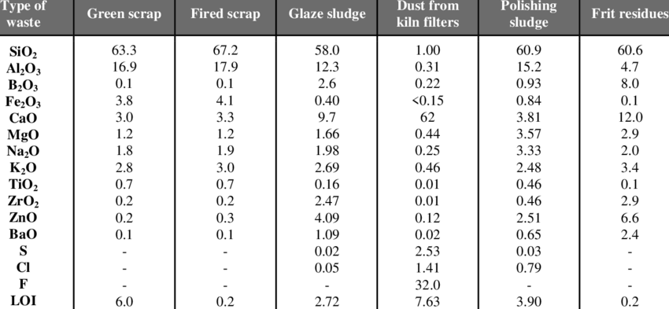

Crushed ceramic waste has a limit percentage of substitution when used as a coarse aggregate. Cachim used partial replacement (15, 20 and 30%) of natural coarse aggregates with crushed and used waste from various kinds of ceramic products, it was noted that 15% substitution did not cause a change in the concrete strength, whilst with 15-20% substitution the strength of concrete varied according to the source of aggregate. 20-30% substitution caused a reduction in the concrete strength regardless of the source of ceramic (Cachim, 2009). Reduction in strength may have resulted after an increase in the flaky aggregate (Tavakoli, 2013). Padmini et al. used a fractional factorial experimental design method to study the comparative influence of various parameters on the strength of concrete using low strength (6 MPa - 13 MPa) bricks as aggregates. It was determined that the strength of the brick was influenced by aggregate conditions (i.e. dry or pre-wet before mixing), cement content and the strength of brick that was crushed to form aggregates (Padmini et al., 2001).

*Table 2.4Properties of ceramic waste (Siddesha H, 2011)*

|  |  |  |
| --- | --- | --- |
| Properties | Crushed Aggregate | Ceramic Aggregate |
| Specific gravity | 2.68 | 2.50 |
| Water absorption % | 0.10 | 0.18 |
| Impact value % | 18.60 | 22 |
| Crushing value % | 15.30 | 20 |
| Abrasion value | 14.25 | 19 |
| Bulk density  Loose condition(kg/m3)  Dense condition (kg/m3) | 1219  1425 | 1069  1188 |

To determine impacts on strength and long term durability of concrete by using different types of brick aggregates, Kibriya and Speare used three types of aggregates. Concrete produced from brick aggregates had a comparable tensile, compressive and flexural strength to those of conventional concrete but modulus of elasticity was significantly reduced (Kibriya and Speare 1996).

Mansur et al. investigated the suitability of crushed bricks as coarse aggregate in concrete, comparing its properties with those of normal concrete, produced from granite aggregates. Four grades from 30 to 60 MPa were used (Mansur et al., 1999). For the same mix proportions, the use of crushed brick aggregates resulted in higher tensile and compressive strengths, lower drying shrinkage and practically an identical specific creep. The use of crushed brick led to a significant loss in workability of fresh concrete and a substantial reduction in the modulus of elasticity.

Ivana et al. determined the density of crushed tiles aggregate micro concrete was found to be 12.7% lower, and density of crushed brick aggregate micro-concrete was found to be 16.4% lower than the control micro concrete density (Ivana et al., 2008). After 28 days, the compressive strength of micro-concrete with crushed tiles was about 32.7% lower and with recycled crushed brick aggregate the strength was about 23.8% lower than that for river aggregate micro-concrete. Ivana et al. concluded that micro-concrete produced with crushed bricks and tile aggregates does not perform in comparison to concrete produced with regular river aggregates in terms of strength. Conversely, the concrete still has adequate strength that would make it suitable for specific applications that require reduction of self-weight due to the benefit of lower density it possess (Ivana et al., 2008).

After 28 days, the flexural strength of microconcrete with crushed tiles was about 40.5% lower and with recycled crushed brick aggregate was about 34.4% lower than the strength of river aggregate microconcrete. From these results it could established that there was a significant reduction in flexural strength when crushed tiles or bricks aggregates was used instead of the conventional river aggregate (Ivana et al., 2008).

Concrete having tiles can consequently be used similarly as conventional concrete (Tavakoli, 2013). Table 3 reveals the results of substitution of coarse aggregate. The report further shows that, compressive strength of concrete increased by 5.1% using a substitution of 10%. Compressive strength of cement using a replacement of 40% remained almost similar to that with 100% normal aggregate. Reduction in strength may have resulted after an increase in the flaky aggregate (Tavakoli, 2013).

Variation in the unit weight was represented in figure 3. Unit weight of concrete reduced as percentage of substitution with tiles increased. The sample that had a 40% replacement had a decrease in unit weight by 2.3%.

**CHAPTER THREE**

**3.0 MATERIALS AND METHOD**

**3.1 RESEARCH MATERIALS**

These are the materials used in carrying out the proposed study. These includes Portland cement, fine aggregates, coarse aggregates, crushed concrete aggregates and water.

**3.1.1 Cement**

Throughout the entirety of the proposed research, Portland limestone cement produced by Dangote PLC was utilized in all mixtures. The BS12-compliant cement was procured from authorized dealers in Port Harcourt, Rivers state.

**3.1.2 Fine Aggregate**

The fine aggregates used were sand, which was sourced locally from the Choba bridge sand deport in Port Harcourt, Rivers state. A visual inspection was conducted to ensure that the sand did not contain any other substances that are likely to decompose or undergo volumetric change when exposed to the elements. The sand was air-dried to remove any moisture in order to ensure that the exact mass of sand was used in the research. In order to determine the particle size distribution of the material, preliminary tests, such as sieve analysis, were conducted. The sand was sieved with a series of standard sieves with a maximum opening size of 4.75 mm.

**3.1.3 Coarse Aggregate**

Granite was sourced locally from a granite deport at Eleme junction in Port Harcourt, Rivers state, for use as coarse aggregate in the experiment. In addition, a visual inspection was conducted to ensure that the granite does not contain any additional materials that are either susceptible to decomposition or have a lower strength than required. The granite was subjected to some preliminary tests, one of which was a sieve analysis to determine the size distribution of the granite. The gravel was passed through a series of 25mm standard sieves.

**3.1.4 Crushed Ceramic Tiles**

ceramic tiles obtained from building demolition sites and left-overs from new building sites in Choba, Rivers state were broken by hammer then washed and dried and grinded to 4mm sizes particle at the grinding mill..It was later sieved through 4.75mm microns and then replaced by percentage dosage of 5, 10, 15 and 20% weight of fine aggregates (sand).

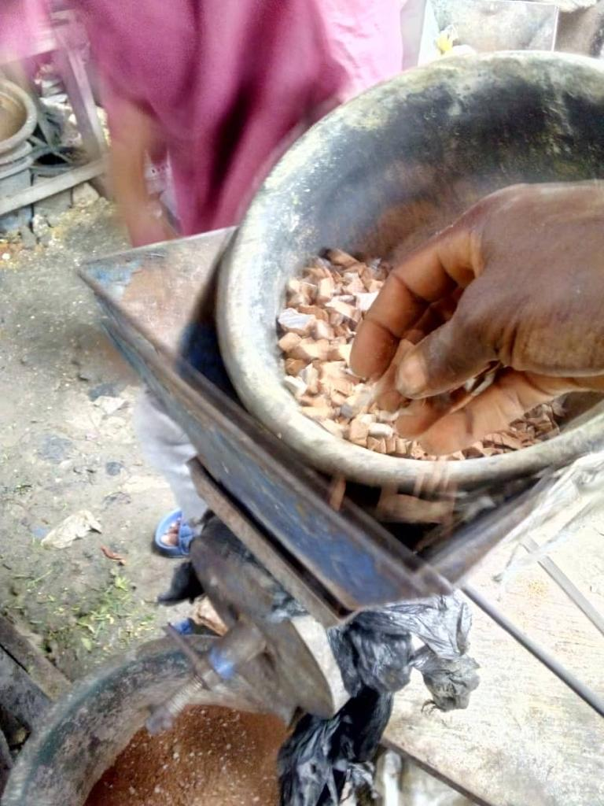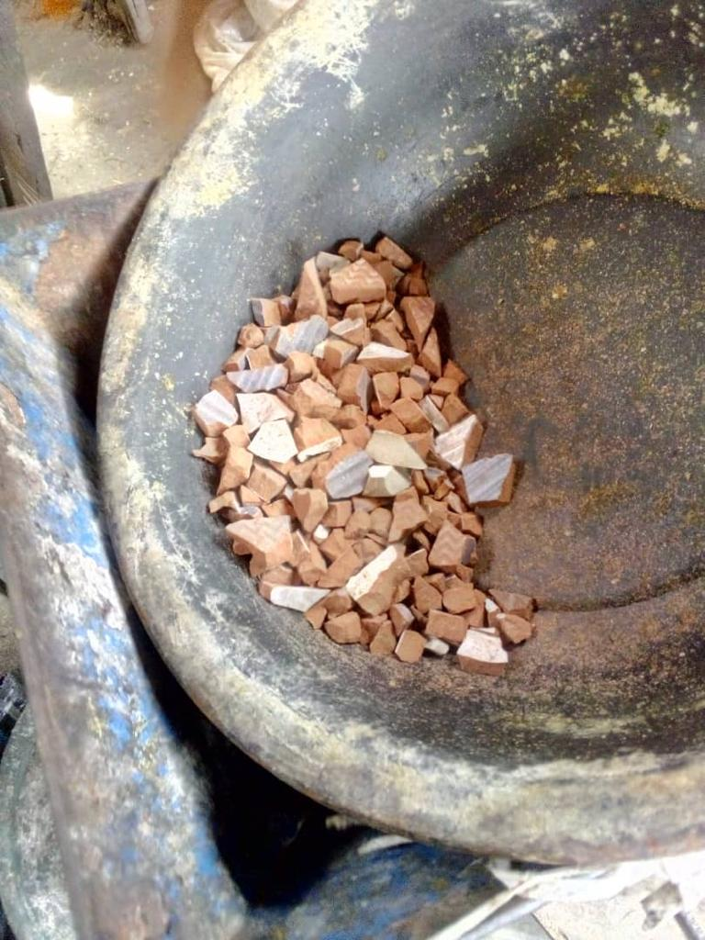

*Plate3.1: crushed ceramic tiles*

**3.1.5 Water**

Portable water was used and it was readily available at the structural laboratory of the University of Port Harcourt, Rivers state. Water used was free of impurities, colourless, odourless and tasteless. Water-cement ratio of 0.55.

**3.2 METHODS**

In this research the mix design was first calculated in order to get the various weight of materials to be used for the experimental phase of the research and various test were also carried out with the sole aim of determining the concrete behavior when the fine aggregate is partially replaced with crushed ceramic tiles. It was ensured that all test carried out was in line with the required standard.

**3.2.1 Mix Design**

The mix design was first calculated to know the exact weight (batching by weight) of each material needed for the mixing of each percentage replacement. A mix design ratio of 1: 2: 4 was used along with a cement-water ratio of 0.55 was adopted. A total of 6 cubes were used for each percentage replacement which implies a total of two (2) cubes for each curing day (7days, 14days and 28days). Concrete moulds of dimension 150mm X 150mm X 150mm was used and it was taking into consideration when calculating the mix design. The mix design calculation result is given in the table below.

|  |  |  |  |  |  |  |  |  |  |
| --- | --- | --- | --- | --- | --- | --- | --- | --- | --- |
| **MIX RATIO** | | | | | **MASS (Kg)** | | | | |
| PORTLAND  CEMENT | RIVER  SAND | CRUSHED  CERAMIC  TILES | GRANITE | WATER | PORTLAND  CEMENT | RIVER  SAND | CRUSHED  CERAMIC  TILES | GRANITE | WATER |
|  |  |  |  |  |  |  |  |  |  |
|  |  |  |  |  |  |  |  |  |  |
|  |  |  |  |  |  |  |  |  |  |
|  |  |  |  |  |  |  |  |  |  |
|  |  |  |  |  |  |  |  |  |  |

**3.2.2 Sieve Analysis**

Sieve analysis was carried out on every aggregate used which includes sand, granite and crushed concrete and this was to determine the particle size distribution of the available aggregate. This test procedure was carried out three times and the mean values were used.

Apparatus used includes:

1. Sensitive weigh balance.
2. Set of sieves which includes 4.75mm, 2.00mm, 1.18mm, 600µm, 300µm, 150µm and pan for fine aggregate and also 25mm, 19mm 13mm, 9.5mm, 4.75mm, 2mm and pan for coarse and crush concrete aggregate.
3. Measuring pan.

Test Procedures carried out is given as follows

1. 1kg of fine aggregate and 2kg of coarse and crush ceramic tiles was firstly measured down and recorded to be used for the test.
2. Every sieve to be used was measured down and recorded.
3. The sieves were ensured it was clean and assembled in ascending order with the biggest sieve at the top and the smallest at the bottom. Also pan was placed at the bottom to collect sample that passed the smallest sieve.
4. The aggregate was poured directly into the sieve and Shaked manually for 10 minutes.
5. Every sieve was weighed along with the sample retained on it.
6. The procedure was carried out two (2) times.

The data analysis was recorded as follows:

1. The mass of the sample retained was recorded by subtracting the weight of the empty sieve from the weight of the sieve with sample retained which is given as ;

Weight of sieve with sample retained – Weight of empty sieve

1. Percentage retained was calculated by dividing the weight retained on each sieve by the original sample mass.
2. Percentage passing was calculated by starting with 100 percent and subtracting the percent retained on each sieve as a cumulative procedure.
3. A semi-log graph was used to plot percentage passing against sieve sizes

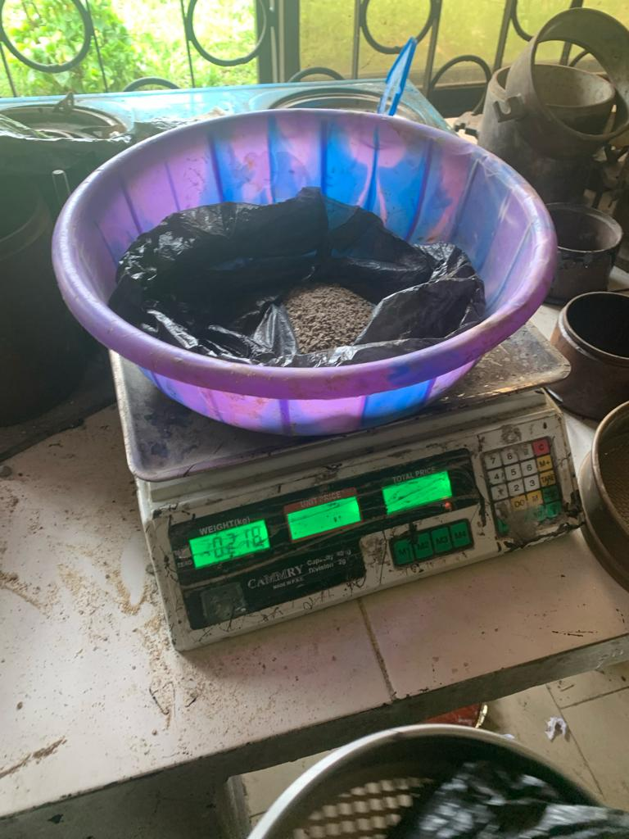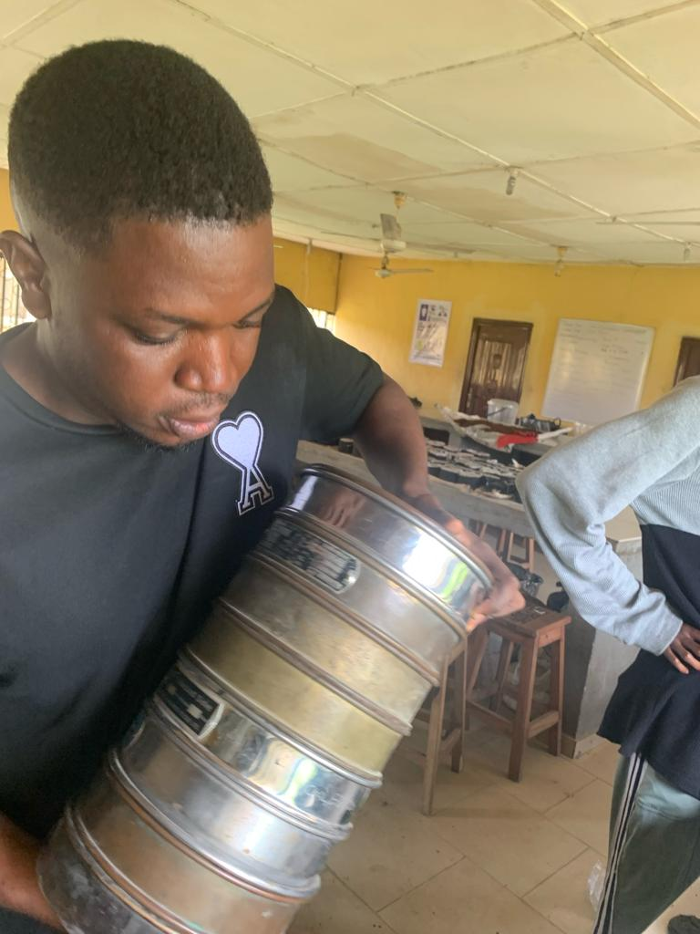

*Plate 3.2: Sieve analysis process*

**3.2.3 Concrete Production**

The materials used were batched in weight as shown in the mix design above. A nominal mix method was used for the research of 1: 2: 4 mixes with a cement-water ratio of 0.55. Steel concrete moulds of 150mm X 150mm X 150mm was used for the casting of the concrete and a total of 30 steel moulds were used, 6 for each percentage replacement

The materials were mixed manually with accordance to the specified mix ratio and cement-water ratio as stated earlier. The moulds were lubricated with oil in order to allow for easy removal of the concrete cubes after hardening. After pouring, tamping rod was used to ensure even distribution of the aggregates within the cubes and also ensure adequate compaction when the concrete was poured inside the moulds.

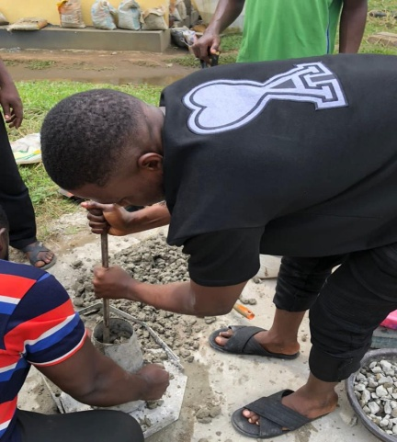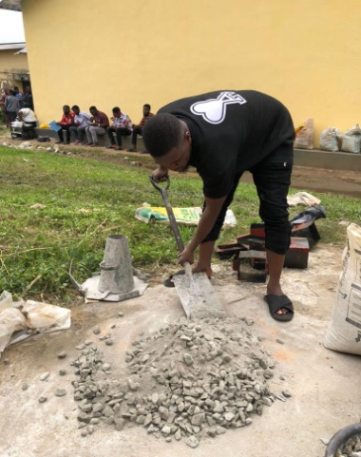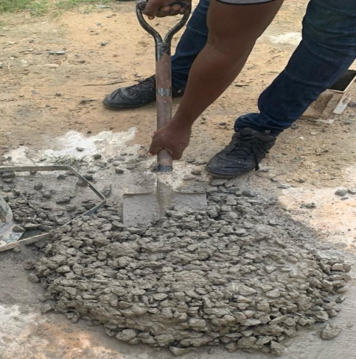 *Plate* 3.3*: Mixing and compaction of concrete*

**3.2.4 Slump Test**

Slump test is the most commonly used method of measuring the consistency (workability) of fresh concrete. It does not accurately measure all factor contributing to the workability of the fresh concrete but it is used conveniently as a control test. The test was carried out for every different percentage replacement.

The test procedures carried out is given as follows:

1. The cone-like mold used for the test was damped and placed on a flat steel board which is moist and nonabsorbent.
2. The cone was filled to 1/3 of its volume from its bottom layer and a rod was used to blow it 25 times and this was done uniformly around the cone. Then the cone was filled to the top and the same rod was used to blow it for another 25 times and any excess concrete from the top was removed. It was ensured the cone was not tilted during the entire process.
3. The cone was removed gently and the difference in height between the cone and the concrete heap was recorded as the slump value.

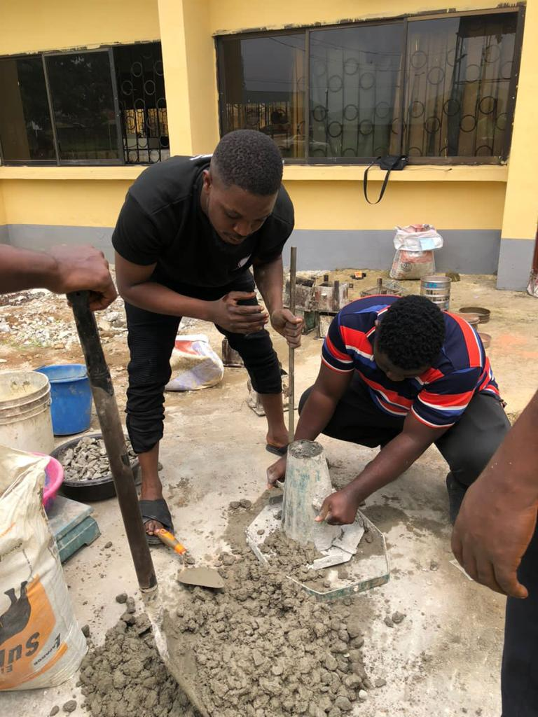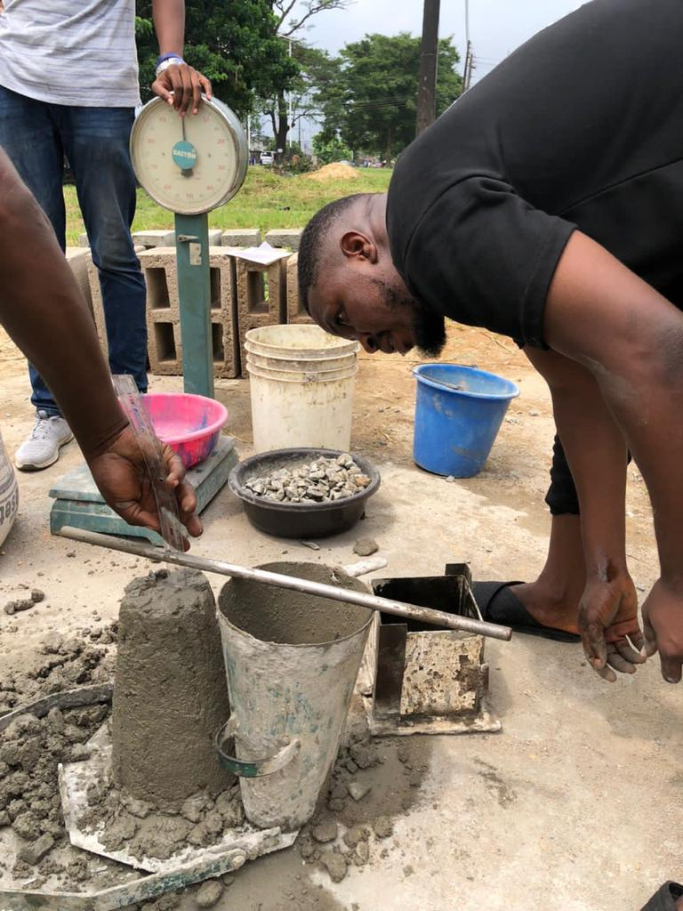 *Plate 3.1: Slump test process*

**3.2.5 Curing**

Curing is the maintenance of a satisfactory moisture content for a period of time after casting so that the desired properties be attained. This is necessary in order for the concrete to attain full strength and also minimize cracks and drying shrinkage in concrete. The concrete cube specimen was cured by complete immersion in water for the required period of hydration (7 days, 14 days and 28 days).

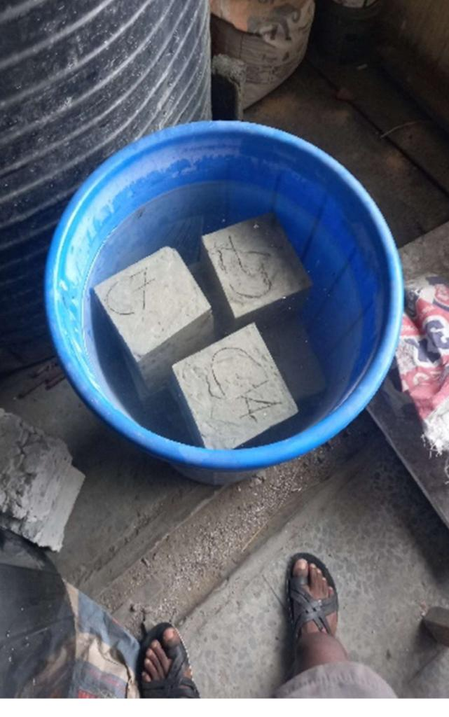 *Plate 3.5 : Curing of concrete cubes*

**3.2.6 Water Absorption**

This test was carried out after the concrete was hardened and removed from the moulds. The water absorption test is carried out to determine the optimum percentage dosage which will give the maximum strength. This test was carried out during the 7 days, 14 days and 28 days period after the concrete was placed inside water (curing period). The process of submerging the concrete cubes in water is called curing.

The test procedures carried out is given as follows:

1. The concrete cubes were weighed after demolding individually and recorded.
2. After 7 days, 14 days and 28 days curing period the concrete cubes were removed from water and weighed again to determine its new weight and recorded.

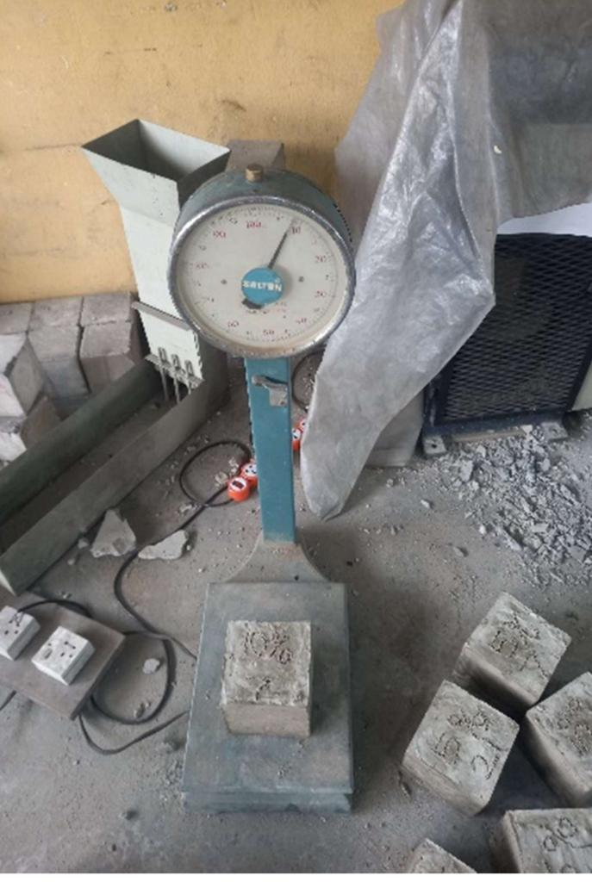 *Plate 3.6:Water absorption test process.*

**3.2.7 Compressive Strength Test**

The compressive strength test was carried out on the concrete cubes for each percentage replacement after each curing period which was 7 days, 14 days and 28 days respectively.

The test procedures carried out is given as follows:

1. The concrete cubes were removed from the curing tank after each hydration day and weighed which was recorded down
2. The surface of the compression test machine was cleaned to remove any particle or previously sample particle left. The machine has a capacity to load about 3000KN
3. The specimen was then placed in the machine in such a way that the load was applied on each opposite sides of the concrete cubes that is not the top or bottom because the top of the cubes tends to be rough.
4. The load was then applied at a constant rate until the concrete cubes failed or break down and the maximum load was then recorded down in KN which was then used in the calculation of the stress given in N/mm2 .

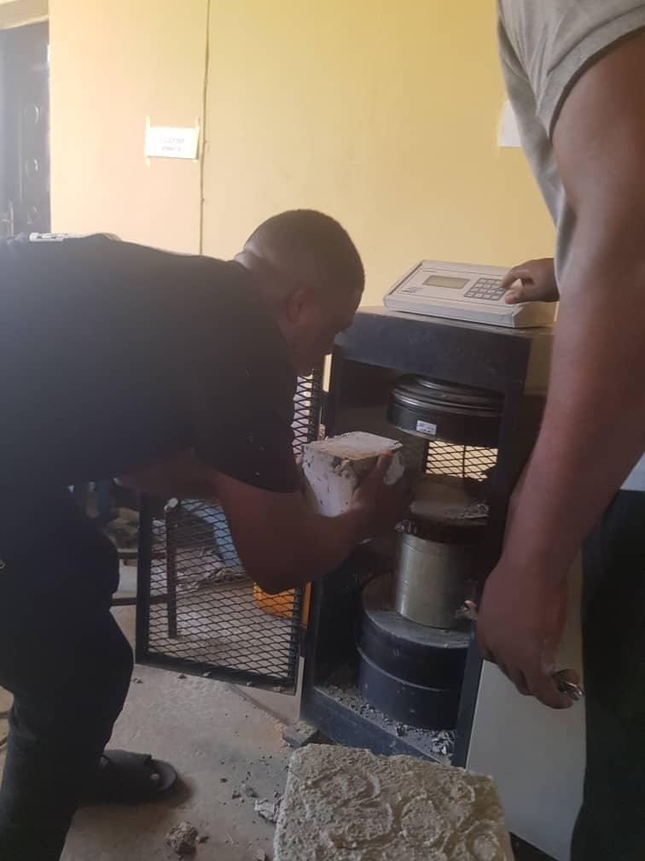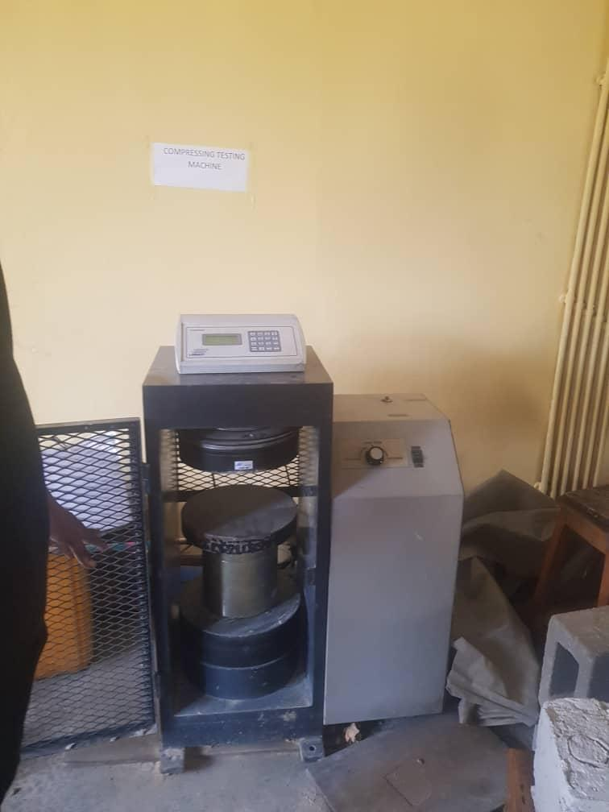 *Plate 3.7: Compressive test ongoing*

**CHAPTER FOUR**

**4.0 RESULTS AND DISCUSSION**

**4.1 Sieve Analysis**

Through the use of sieve analysis, we were able to determine the particle size distributions of all aggregates. The aggregates that were kept for fine aggregate, coarse aggregate, crushed ceramic tiles and the percentage passing for each sieve sizes are listed in tables 4.1.1, 4.1.2, and 4.1.3, respectively. The particle size distribution of fine aggregates can be determined by using sieves with maximums of 4.5 mm and minimums of 150μm. For coarse aggregates and crushed concrete, the maximum sieve size is 25 mm and the minimum sieve size is 2 mm. Fine aggregates have a fineness modulus of 2.81, coarse aggregates have a fineness modulus of 4.45 and crushed ceramic tiles has a fineness modulus of 3.2. This indicates that fine aggregate and crushed ceramic tiles is comparable to medium sand, while coarse aggregate is comparable to coarse gravel.

*Table 4.1.1: Sieve Analysis for Fine Aggregate.*

|  |  |  |  |  |  |
| --- | --- | --- | --- | --- | --- |
| Sieve Size | Amount  Retained  (g) | Cumulative  Amount  Retained  (g) | Percentage  Retained  (%) | Cumulative  Percentage  Retained  (%) | Percentage  Passing |
| 4.75mm | 0.012 | 0.012 | 1.2 | 1.2 | 98.9 |
| 2.00mm | 0.231 | 0.243 | 23.1 | 24.3 | 75.7 |
| 1.18mm | 0.040 | 0.283 | 4.1 | 28.4 | 71.6 |
| 600µm | 0.171 | 0.454 | 17.1 | 45.5 | 54.5 |
| 300 µm | 0.412 | 0.866 | 41.2 | 86.7 | 13.3 |
| 150 µm | 0.080 | 0.946 | 8.0 | 94.7 | 5.4 |
| Pan | 0.054 | 1.000 | 5.4 | 100 | 0 |

*Table 4.1.2: Sieve Analysis for coarse Aggregate*

|  |  |  |  |  |  |
| --- | --- | --- | --- | --- | --- |
| Sieve Size | Amount  Retained  (g) | Cumulative  Amount  Retained  (g) | Percentage  Retained  (%) | Cumulative  Percentage  Retained  (%) | Percentage  Passing |
| 25mm | 0.182 | 0.182 | 9.10 | 9.1 | 90.8 |
| 19mm | 0.872 | 1.054 | 43.50 | 52.7 | 47.3 |
| 13mm | 0.696 | 1.750 | 34.80 | 87.5 | 12.5 |
| 9.5mm | 0.167 | 0.917 | 8.35 | 95.85 | 4.15 |
| 4.75mm | 0.075 | 1.992 | 3.75 | 99.6 | 0.4 |
| 2mm | 0.008 | 2.000 | 0.40 | 100 | 0 |
| Pan | 0 | 2.000 | 0 | 100 | 0 |

*Table 4.1.3: Sieve Analysis for crushed ceramic tiles*

|  |  |  |  |  |  |  |  |  |
| --- | --- | --- | --- | --- | --- | --- | --- | --- |
| Sieve Size | Amount  Retained  (g) | Cumulative  Amount  Retained  (g) | | Percentage  Retained  (%) | | Cumulative  Percentage  Retained  (%) | Percentage  Passing | |
| 4.75mm | 0.006 | 0.006 | | 0.6 | | 0.6 | 99.4 | |
| 2.36mm | 0.072 | 0.078 | | 7.2 | | 7.8 | 92.2 | |
| 2.0mm | 0.074 | 0.152 | | 7.4 | | 15.2 | 84.8 | |
| 1.4mm | 0.458 | 0.61 | | 45.8 | | 61 | 39 | |
| 1.18mm | 0.02 | 0.63 | | 2 | | 63 | 37 | |
| 1mm | 0.2 | 0.83 | | 20 | | 83 | 17 | |
| 0.3mm | 0.16 | 0.99 | | 16 | | 99 | 1 | |
| Pan | 0.01 | | 1.000 | 1.000 | 100 | | | 0 |

*Figure 4.1.1: Particle Size Distribution Curve for Fine Aggregate and Crushed*

*Ceramic Ties*

For Fine Aggregates D60, D30, and D10 are 0.787mm, 0.422mm, and 0.237mm, respectively, as shown in Figure 4.1.1; thus,

The uniformity coefficient (Cu) and coefficient of curvature (Cc)

Since Cu is less than 4, it is uniformly graded.

For Crushed Ceramic Tiles D60, D30, and D10 are 1.68mm, 1.12mm, and 0.69mm, respectively, as shown in Figure 4.1.1; thus,

The uniformity coefficient (Cu) and coefficient of curvature (Cc)=

Since Cu is less than 4, it is uniformly graded.

*Figure 4.1.2: Particle Size Distribution Curve for Coarse Aggregate*

. Tiles D60, D30, and D10 are 20.75mm, 16.11mm, and 11.95mm, respectively, as shown in Figure 4.1.1; thus,

The uniformity coefficient (Cu) and coefficient of curvature (Cc)=

Since Cu is less than 4, it is uniformly graded

**4.2 Slump Test**

We were able to determine the workability of both fresh concrete and concrete made with crushed ceramic tiles by using the slump test. A mixture of concrete with a lower slump value is more workable than one with a higher slump value. Below is the table containing the results of the slump test?

*Table 4.2.1: Slump test result data*.

|  |  |
| --- | --- |
| Percentage Replacement (%) | Slump Value (mm) |
| 0 | **42** |
| 5 | **32** |
| 10 | **25** |
| 15 | **16** |
| 20 | **12** |

*Figure 4.2.1: Chart showing the percentage replacement against slump value*

From *fig.4.2.1* above, it was observed that the conventional concrete produced 42mm slump height, on proceeding to 5% replacement of CCT the slump gradually reduced to 32mm, on getting to 10% height of slump dropped to 25mm and on replacing 15% of CCT with sharp sand the height drastically reduced to 16mm and substituting with 20% the slump reduced abruptly to 12mm.All these slump calibrated were classified as true slump which falls within the range of 0 and 50mm. As the Crushed Ceramic Tiles (CCT) increases the slump height also reduces which is due to the high water absorption in ceramic aggregate.

**4.3 Water Absorption**

Water absorption test was carried out on the specimen sample, the weight and water absorption percentage of the cubes after demoulding as well as after 7 days, 14 days and 28 days curing period are recorded in table below

*Table 4.3.1: Weight of Sample after Demoulding*

|  |  |
| --- | --- |
| Percentage Replacement  (%) | Weight of Sample  (kg)  Demoulding |
| 0 | 8.3 |
| 5 | 8.1 |
| 10 | 7.8 |
| 15 | 8.0 |
| 20 | 7.3 |

*Table 4.3.2: Water absorption data for weight of 7, 14 and 28 days curing period*

|  |  |  |  |  |  |  |
| --- | --- | --- | --- | --- | --- | --- |
| Percentage  Replacement  (%) | Weight  7Days  (kg) | Percentage  Weight  (%) | Weight  14Days  (kg) | Percentage  Weight  (%) | Weight  28Days  (kg) | Percentage  Weight  (%) |
| 0 | 8.3 | 0 | 8.4 | 1.19 | 8.6 | 3.48 |
| 5 | 8.0 | 1.23 | 8.0 | 1.23 | 8.3 | 2.41 |
| 10 | 7.9 | 1.26 | 8.0 | 2.50 | 8.2 | 4.87 |
| 15 | 8.1 | 1.23 | 8.2 | 2.44 | 8.3 | 3.6 |
| 20 | 7.6 | 3.94 | 7.6 | 3.94 | 7.9 | 7.59 |

*Figure 4.3.1: Chart of water absorption showing varying percentage passing against weight for all curing period.*

The concrete cubes at 7days, 14days and 28days curing were weighed after demoulding. It was shown that increase in CCT led to decrease in water absorption of concrete as shown in Fig 4.3.1.

**4.4 Compressive Strength**

Compressive strength tests were conducted on cured cube specimen a 7days , 14days and 28days using a compression testing machine of 3000KN load capacity. The Cubes were fitted at the center in compression testing machine and fixed to keep the cube in position. The Load was then slowly applied to the tested cube until failure.

Concrete cubes of size 150mm x 150mm x 150mm were casted for 0%, 5%, 15% and 20%, ceramic aggregate replacement. The Compressive strength for M15 grade concrete is tested for 7, 14 and 28days of curing and the results are tabulated and plotted below.

*Table 4.4.1: Compressive strength for 0% replacement.*

|  |  |  |  |
| --- | --- | --- | --- |
| **Compressive Strength for Natural Aggregate (0% Replacement)** | | | |
| Age (days) | Failure Load  (KN) | Stress  (N/mm2) | Average Stress  (N/mm2) |
| 7 | 463.50 | 20.60 | 19.9 |
| 432.00 | 19.20 |
| 14 | 495.67 | 22.03 | 21.81 |
| 485.77 | 21.59 |
| 28 | 528.75 | 23.50 | 24.15 |
| 558.00 | 24.80 |

*Figure 4.4.1: Compressive Strength for 0% replacement*

*Table 4.4.2: Compressive strength for 5% replacement.*

|  |  |  |  |
| --- | --- | --- | --- |
| **Compressive Strength for Natural Aggregate (5% Replacement)** | | | |
| Age (days) | Failure Load  (KN) | Stress  (N/mm2) | Average Stress  (N/mm2) |
| 7 | 352.13 | 15.65 | 15.73 |
| 355.50 | 15.80 |
| 14 | 364.50 | 16.20 | 16.09 |
| 359.55 | 15.98 |
| 28 | 483.75 | 21.50 | 22.08 |
| 509.63 | 22.65 |

*Figure 4.4.2: Compressive Strength for 5% replacement*

*Table 4.4.3: Compressive strength for 10% replacement*

|  |  |  |  |
| --- | --- | --- | --- |
| **Compressive Strength for Natural Aggregate (10% Replacement)** | | | |
| Age (days) | Failure Load  (KN) | Stress  (N/mm2) | Average Stress  (N/mm2) |
| 7 | 401.63 | 17.85 | 18.40 |
| 426.38 | 18.95 |
| 14 | 442.80 | 19.68 | 20.00 |
| 457.20 | 20.32 |
| 28 | 552.00 | 23.20 | 24.40 |
| 576.00 | 25.60 |

*Figure 4.4.3: Compressive Strength for 10% replacement*

*Table 4.4.4: Compressive strength for 15% replacement.*

|  |  |  |  |
| --- | --- | --- | --- |
| **Compressive Strength for Natural Aggregate (15% Replacement)** | | | |
| Age (days) | Failure Load  (KN) | Stress  (N/mm2) | Average Stress  (N/mm2) |
| 7 | 384.75 | 17.10 | 16.75 |
| 369.00 | 16.40 |
| 14 | 436.50 | 19.40 | 18.95 |
| 416.25 | 18.50 |
| 28 | 495.00 | 22.00 | 22.69 |
| 526.06 | 23.38 |

*Figure 4.4.4: Compressive Strength for 15% replacement*

*Table 4.4.5: Compressive strength for 20% replacement*

*Figure 4.4.5: Compressive Strength for 20% replacement*

|  |  |  |  |
| --- | --- | --- | --- |
| **Compressive Strength for Natural Aggregate (20% Replacement)** | | | |
| Age (days) | Failure Load  (KN) | Stress  (N/mm2) | Average Stress  (N/mm2) |
| 7 | 244.13 | 10.85 | 11.18 |
| 258.75 | 11.50 |
| 14 | 371.25 | 16.50 | 15.85 |
| 342.00 | 15.20 |
| 28 | 401.40 | 17.84 | 18.03 |
| 409.95 | 18.22 |

*Table 4.4.8: Compressive strength for varied percentage replacement*

|  |  |  |  |  |  |
| --- | --- | --- | --- | --- | --- |
| **Compressive Strength for all Varied Percentage Replacement** | | | | | |
| Ages(Days) | 0% | 5% | 10% | 15% | 20% |
| 7 | 19.9 | 15.73 | 18.4 | 16.75 | 11.18 |
| 14 | 21.81 | 16.09 | 20 | 18.95 | 15.85 |
| 28 | 24.15 | 22.08 | 24.4 | 22.69 | 18.03 |

*Figure 4.4.8: Compressive Strength for varied percentage replacement*

The Compressive Strength Vary depending on the percentage replacement of Crushed ceramic tiles as shown in the chart above.

With 10% replacement attaining the maximum strength aside the control mix.20% having the minimum strength attained.

**CHAPTER FIVE**

**5.0 CONCLUSION AND RECOMMENDATION**

Based on the results of the experimental work carried out in this research, the following conclusion could be drawn.

1. Decrease in workability was detected as the percentage of replacement increase since ceramic has high water absorption. Therefore, slump decreases as percentage of crushed ceramic waste replacement increases for all cases.
2. The Concrete with 5%, 10% and 15% replacement satisfies the compressive strength of M15.

Hence the replacement of river sand using 10% ceramic waste in concrete gives the required strength and can be considered as optimum percentage.

**REFERENCES**

Gagg, O. (2014). Concrete. In Civil Engineering Materials (pp. 31-61). Springer, Dordrecht.

Li, Q. (2011). The History of Concrete and its Use in China. In Science and Technology of Ancient China (pp. 161-175). Springer, Dordrecht.

Kolo, Y. B. (2015). An assessment of the use of quarry dust as partial replacement of fine aggregate in concrete. International Journal of Civil Engineering and Technology, 6(8), 45-51.

Raqifa, I. (2011). Properties of Concrete. LAP LAMBERT Academic Publishing.Portland Cement Association (PCA). (2019). Design and Control of Concrete Mixtures (Fifteenth Edition). Skokie, Illinois: Portland cement Association.

Katz, A. (2003). Chemistry for Sustainable Technologies. John Wiley & Sons.

Mehta, P. K. (1993). Concrete: Structure, properties, and materials. McGraw-Hill.

Kosmatka, S. H. (1994). Design and control of concrete mixtures. Portland Cement Association.

Illston, J. M. (1994). Concrete. Granada: McGraw-Hill.

Rahul, R. (2015). Concrete Technology: A Comprehensive Guide. New Delhi: Firewall Media.

Brook, K. M. (1991). Lightweight aggregates in concrete. In: ACI Special Publication 139: Performance of Concrete at Early Ages (pp. 169-185). American Concrete Institute.

Neville, A. M. (2011). Properties of concrete. London: Pearson Education Limited.

Mehta, P. K., & Monteiro, P. J. M. (2014). Concrete: microstructure, properties, and materials. McGraw-Hill Education.

koyuncu H. et al. (2004). Use of crushed ceramic waste in road bases. Materials & Structures, 37(8), 539-548.

Weil, M., Jeske, J., & Schebek, L. (2006). Construction materials made from recycled aggregates. Waste Management, 26(7), 890-897.

Odero, B. J., John, P. M., & Kinuthia, J. B. (2014). Comparative study of properties of lightweight concrete incorporating ceramic tile waste as aggregate. International Journal of Civil Engineering and Technology (IJCIET), 5(8), 75-87.

Pacheco-Torgal, F., Jalali, S., Labrinopoulos, J. F., & Varum, H. S. (2010). Reusing ceramic wastes in eco-efficient construction: a review of the potential. Journal of Materials Science, 45(18), 4986-5000.

D. Tavakoli; A. Heidari and M. Karimian (2013). Application of waste ceramic tile in structural lightweight concrete. Construction and Building Materials, 44, 542-550.

Nadeem, M., Javed, M. H., Mushtaq, M., & Majeed, A. (2012). Recycling of waste ceramic tiles in structural concrete. Construction and Building Materials, 34, 124-132.

T. Sekar et al. (2011). Sustainability and environmental impact of utilizing waste ceramic materials in concrete- A review. ARPN Journal of Engineering and Applied Sciences, 6(8), 1463-1469.

Sudarsana Rao Hunchate (2013). Performance of recycled ceramic tile waste as aggregate in concrete. International Journal of Civil and Structural Engineering, 3(3), 349-354.

Siddesha (2011). Effect of using ceramic waste as fine aggregate in concrete. International Journal of Engineering Science and Technology, 3(8), 5533-5536.

Punit Malik et al. (2014). Use of ceramic tile waste as coarse aggregate in concrete. International Journal of Civil and Structural Engineering, 4(4), 429-436.

Ay, T., & Unal, A. (2000). Use of waste ceramic tile powder as an additive in Portland cement mortar and concrete. Cement and Concrete Research, 30(8), 1229-1235.

Khaloo, A. R. (1995). Properties of concrete made with waste ceramic tile. Construction and Building Materials, 9(3), 153-158.

Akhtaruzzaman, A. H., & Hasnat, A. (1988). Use of crushed brick aggregate in concrete. Construction and Building Materials, 2(3), 125-129.

Pacheco-Torgal, F., & Jalali, S. (2010). Chemical composition of ceramic pastes. *Journal of Materials Science*, 45(18), 4986-5000.

Cachim, P. B. (2009). Experimental study of coarse recycled ceramic aggregate concrete. Construction and Building Materials, 23(2), 721-728.

Tavakoli, D. (2013). Application of waste ceramic tile in structural lightweight concrete. Construction and Building Materials, 44, 542-550.

Padmini, A., Ramachandra Rao, P. S., & Seshagiri Rao, P. V. (2001). Performance of concrete with crushed clay brick aggregate. Cement and Concrete Research, 31(10), 1457-1462.

Kibriya, A. A., & Speare, P. R. (1996). Use of recycled brick aggregate in concrete masonry. Structural Survey, 14(4), 14-20.

Mansur, M. A., Anggono, I., & Wee, T. H. (1999). Properties of lightweight concrete prepared using crushed clay brick as coarse aggregate. Cement and Concrete Composites, 21(2), 125-131.

Ivana, B., Milena, K., & Branko, V. (2008). Utilization of waste ceramic tiles and crushed bricks in the production of lightweight concrete. Waste Management, 28(12), 2482-2491.

Tavakoli, D. (2013). Application of waste ceramic tile in structural lightweight concrete. Construction and Building Materials, 44, 542-550.